Types of Join:

1. NATURAL JOIN
2. Join with USING clause
3. Join with ON clause
4. OUTER joins

* LEFT OUTER JOINS
* RIGHT OUTER JOINS
* FULL OUTER JOINS

5. CROSS JOIN (CARTESIAN PRODUCT)

---------------------------------------------------------------------------------------------------------------------------------------**NATURAL JOIN: Apna Logic ( where department_id=? and manager_id=?)**

* Join two table with the columns that have same name.
* Select rows from two tables that have the equal values in the same columns.
* If two columns have same name but different data type , it will give error.

select employees.FIRST_NAME ,employees.LAST_NAME,DEPARTMENTS.DEPARTMENT_NAME from employees natural join DEPARTMENTS;

select FIRST_NAME ,LAST_NAME,DEPARTMENT_NAME from employees natural join DEPARTMENTS;

--Note Both query have same output

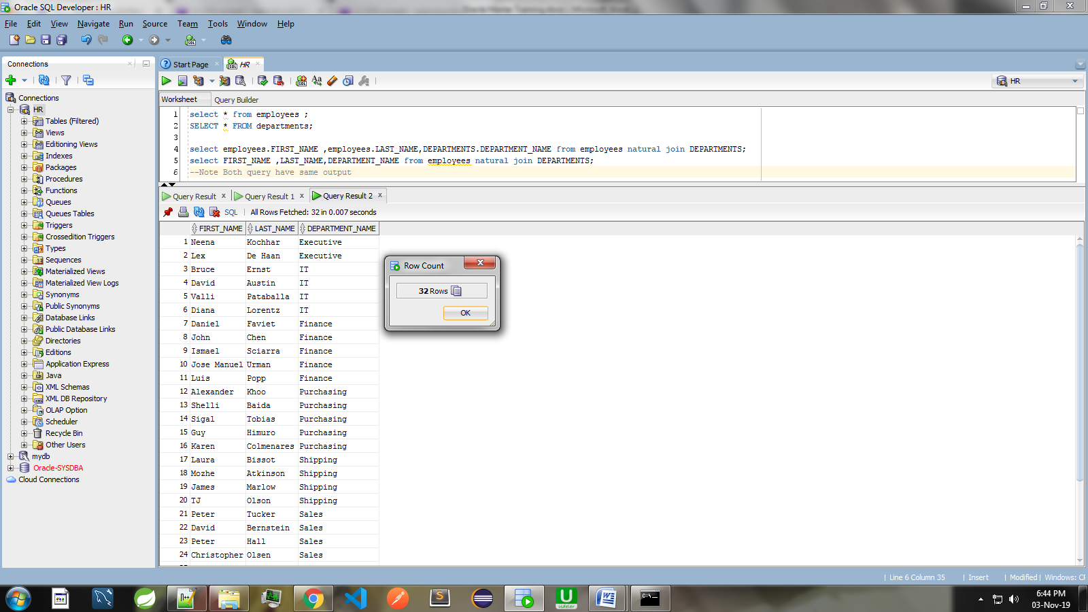

**NOTE: JOIN with USING clause i.e USING (department_id) , USING (department_id,manager_id) this can be only used when column name must be same in both the tables other wise use ON.**

**case 1: Both are same, for first column name should be same,for second column name can be different.**

**USING (department_id) OR ON e. department_id = d. department_id;**

**case 2: Both are same, for first column name should be same,for second column name can be different.**

**USING (department_id, manager_id) OR ON e. department_id = d. department_id and**

**e. manager_id = d. manager_id;**

**NATURAL JOIN with USING clause: Only Department_ID**

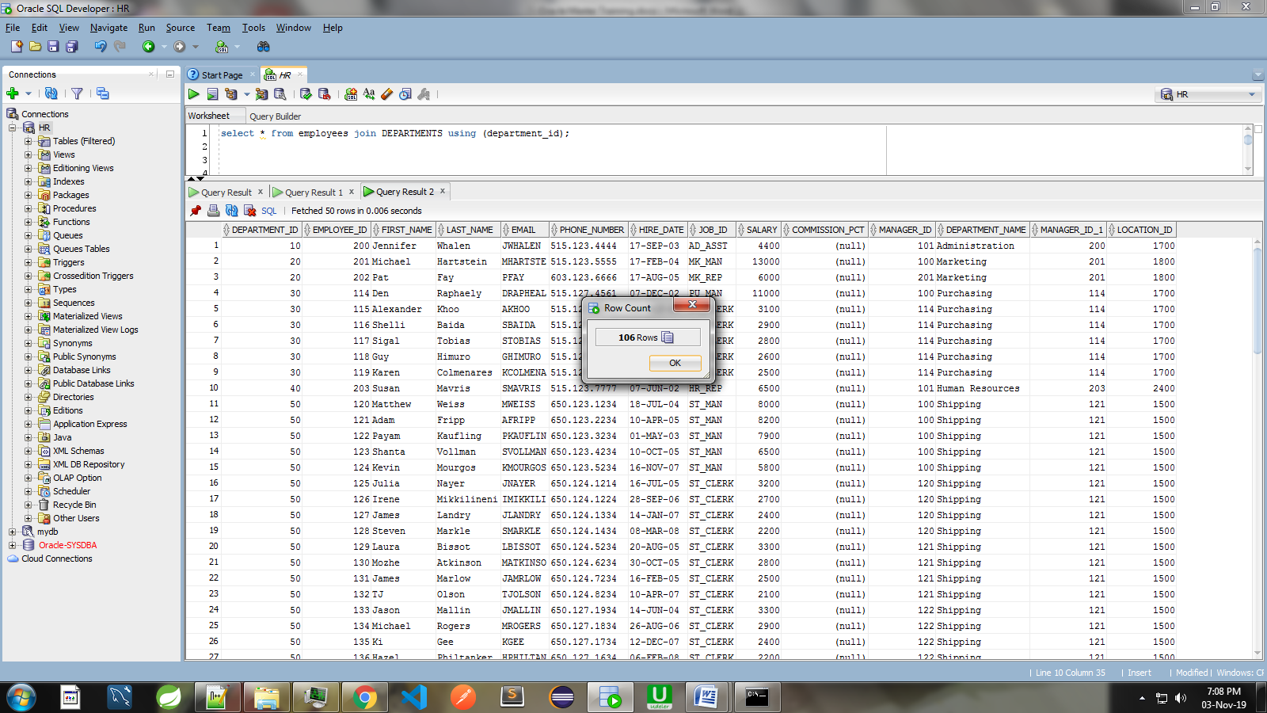

**NATURAL JOIN with USING clause: Department_ID , Manager_ID**

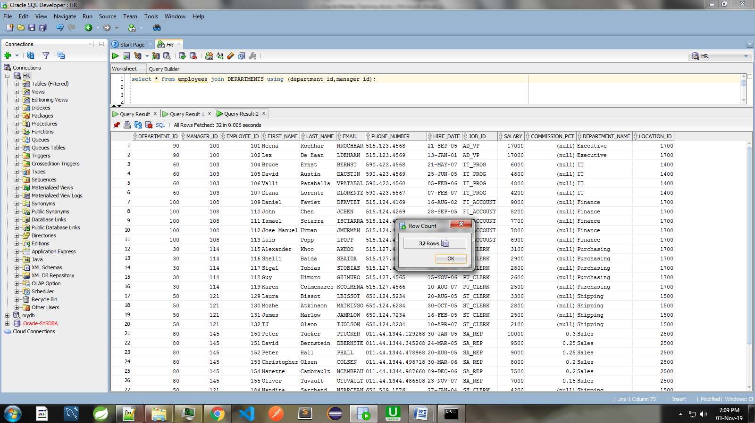

**Handling Ambiguous Column Name:**

1. Table aliases are used for handling duplicates column names in two tables.

**Here compiler wont to come to know from which table manager_id column should get select?**

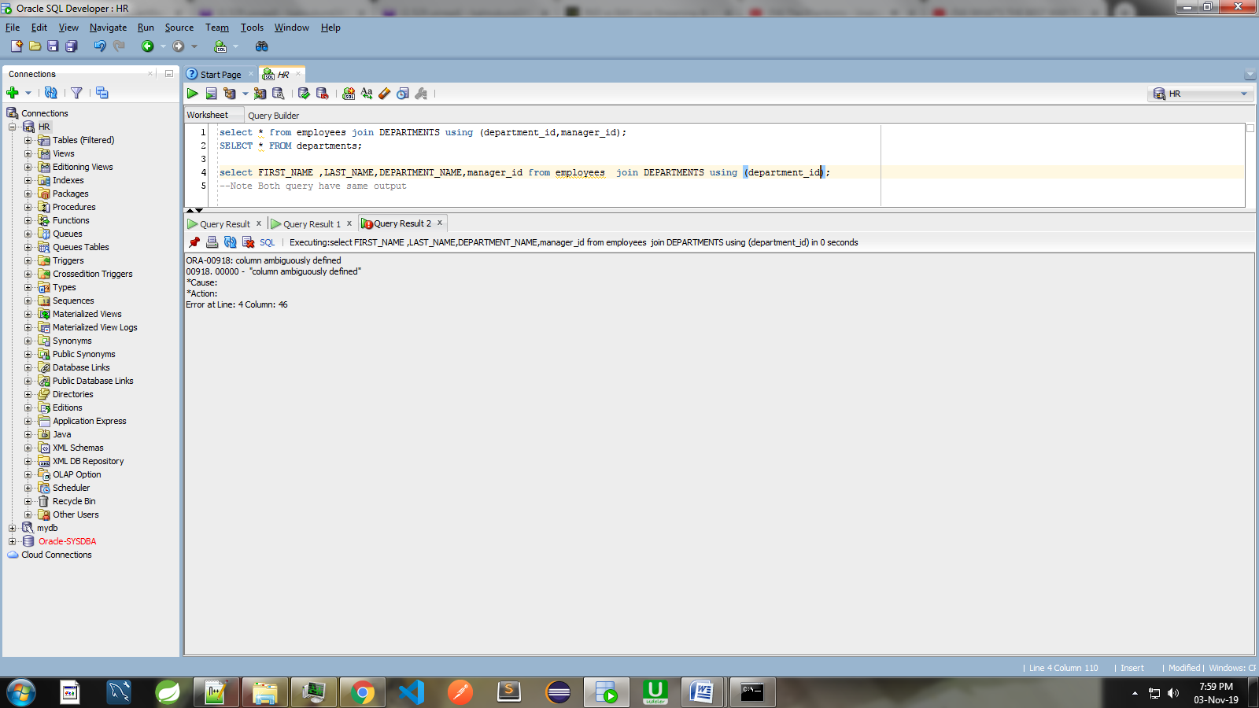

**2. With table aliases we can specify column name that we want to use.**

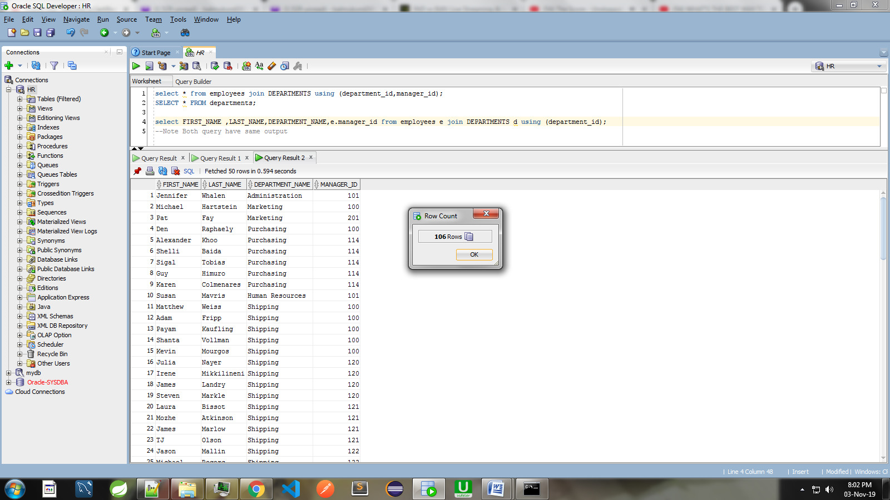

**3. We cannot give an alias to a column that is** **USING** **clause or** **NATURAL JOIN**

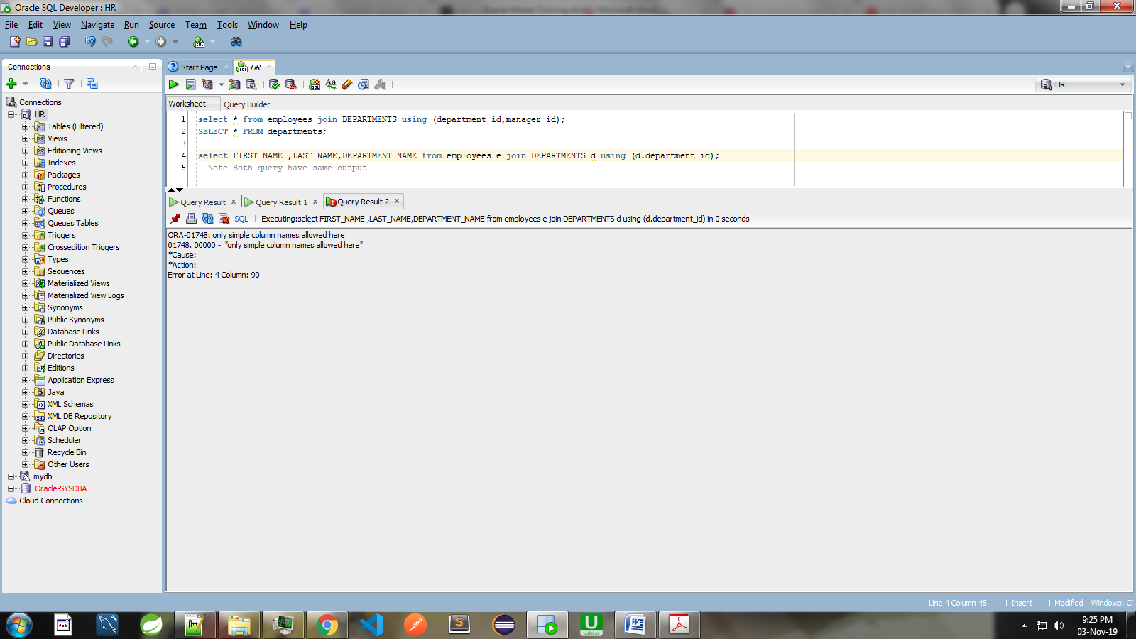

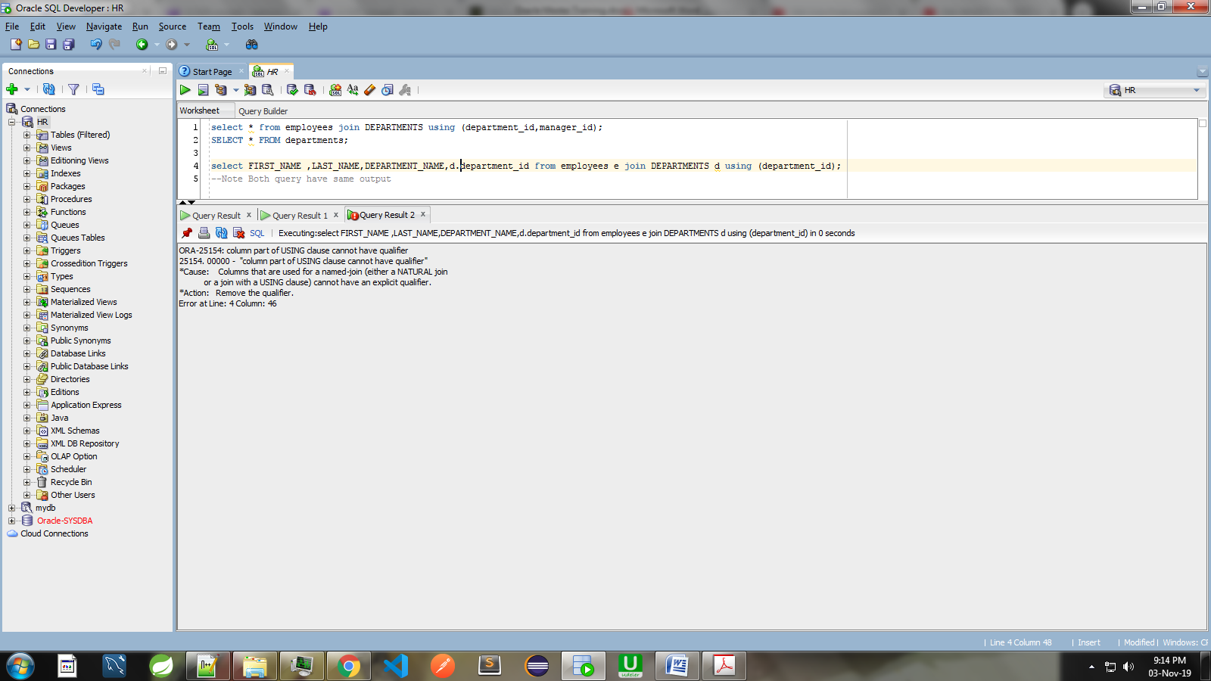

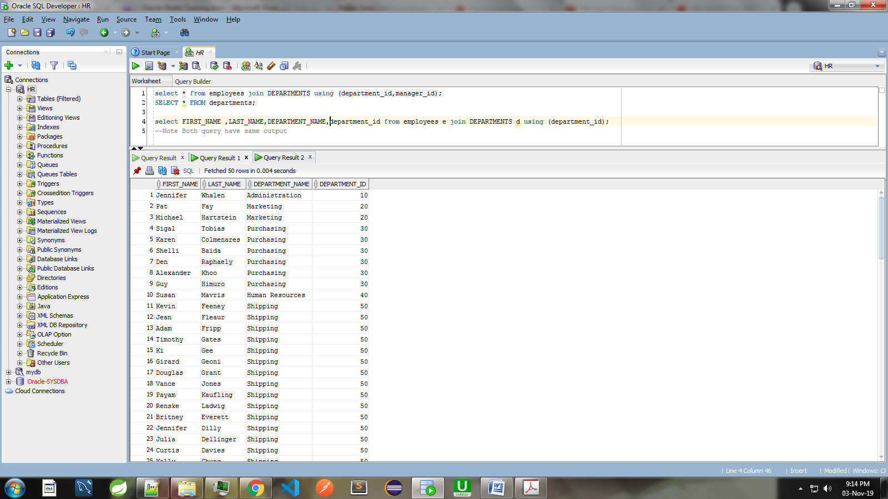

**Join with ON clause: Between Two Table**

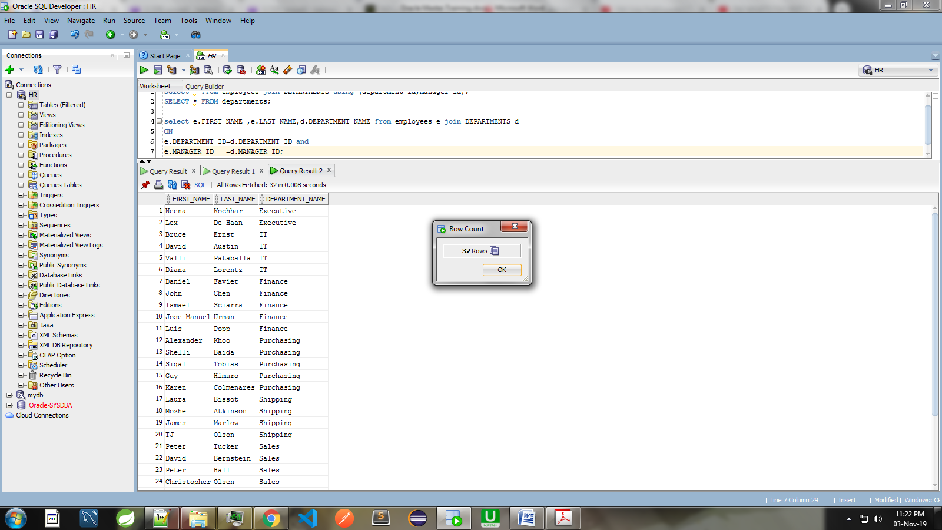

**Multiple JOINS Operations:**

**Join with ON clause: More than Two Table i.e 3 Tables**

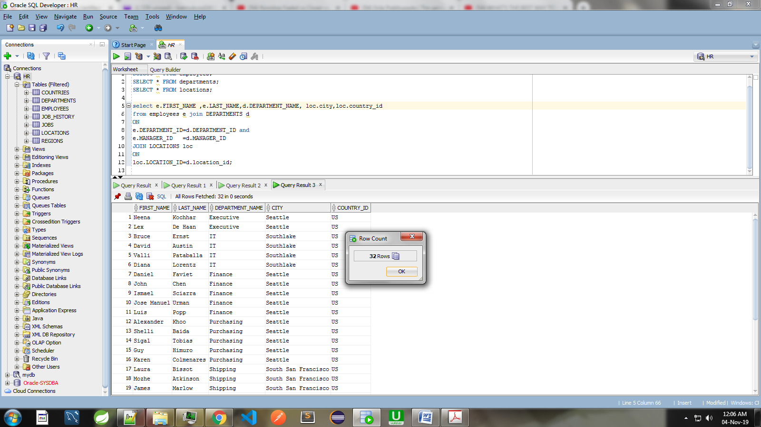

**Restricting JOINS:**

**We can restrict joins with using WHERE clause and AND operators. Both will give same output**

